FROST NATIONAL BANK – FIS UPGRADE AUTOMATION PLAN

Date: May 21, 2018

Prepared by: HCL Technologies Ltd
Version – 1.0

Table of Contents

Introduction 3
1.1 Objectives 3
2 Scope 3
1.1 IN - SCOPE 3
1.1 OUT OF SCOPE 3
3 AUTOMATION APPROACH 3
3.1 AUTOMATION DESIGN 4
3.2 STANDARD AND GUIDELINES 4
3.3 DEPENDENCIES LIST 4
4 Assumptions / Risks 4
4.1 Assumptions 4
4.2 Risks 4
5 EXECUTION Approach 4
5.1 Test Automation 4

Introduction
The Test Plan has been created to communicate the test approach to team members. It includes the objectives, scope, schedule, risks and approach. This document will clearly identify what the test deliverables will be and what is deemed in and out of scope.

Objectives
Test Case Tamer is a web-based Test Management tool used to create and store tests as well as the results of running those tests. This tool is a new product written with Ruby on Rails using a ‘mysql’ database. The test team is responsible for testing the product and ensuring it meets their needs. The test team is both the customer and the tester in this project.

Scope
The initial phase will include all ‘must have’ requirements. These and any other requirements that get included must all be tested. At the end of Phase 1, a tester must be able to:

In Scope

Out of Scope

Automation Approach

Automation Design
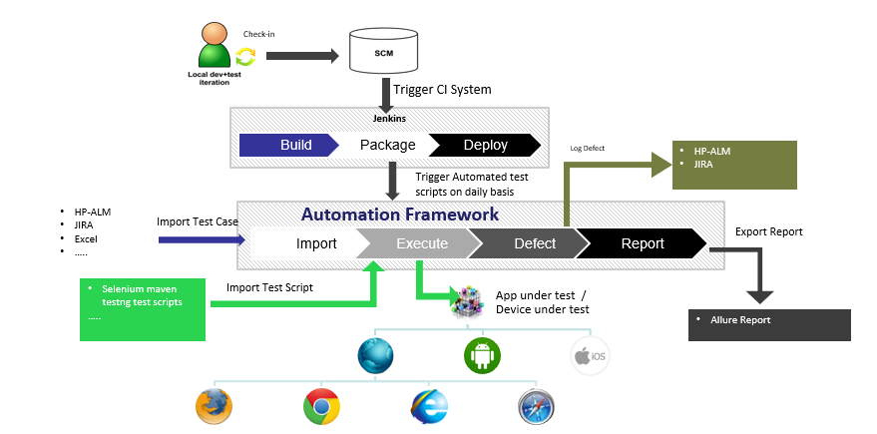

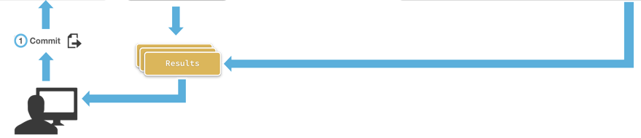
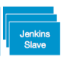
Bit Bucket
Test automation code
Test data
Test Configuration
Jenkins CI
Upload to Test Cloud
Build tests
Run automated tests at 8pm everyday in VDIs or cloud
Tester

Standards and Guidelines

3.3 Automation Dependencies
a) Platform - Windows 7,8,10
b) Development Environment - Eclipse IDE
c) Browsers - Chrome, IE(on Windows only), Firefox
d) Language - Java JDK 8
e) Build Tool - Apache maven 3.3.0
f) Test Runner – TestNG for Eclipse
g) Continuous Integration Tool – Jenkins version 2.107.1 for Windows
h) Code Repository - Github, bitbucket
i) Version Control System – Git Bash, Git UI
j) Browser exe files – chromedriver, geckodriver, IEDriverServer
k) Excel Reading Writing Jar – Apache POI 3.17 jar
l) Reporting Jars - Extent report 3.1.5 jar and allure-testng 2.0-BETA14 jar
m) Additional jars required ₋ selenium-java 3.8.1 jar, testng 6.8.8 jar, slf4j-simple 1.7.21 jar, junit 3.8.1 jar
n) Additional plugins required ₋ maven compiler plugin 2.7.2, maven failsafe plugin 2.7.2, maven sure fire plugin 2.7.2

Assumptions / Risks

Assumptions
This section lists assumptions that are made specific to this project.
- Delivery of the product is in format that the test team can check it into CVS.

Risks
The following risks have been identified and the appropriate action identified to mitigate their impact on the project. The impact (or severity) of the risk is based on how the project would be affected if the risk was triggered. The trigger is what milestone or event would cause the risk to become an issue to be dealt with.

# | Risk | Impact | Trigger | Mitigation Plan
1 | Scope Creep – as testers become more familiar with the tool, they will want more functionality | High | Delays in implementation date | Each iteration, functionality will be closely monitored. Priorities will be set and discussed by stakeholders. Since the driver is functionality and not time, it may be necessary to push the date out.
2 | Changes to the functionality may negate the tests already written and we may loose test cases already written | High – to schedule and quality | Loss of all test cases | Export data prior to any upgrade, massage as necessary and re-import after upgrade.
3 | Weekly delivery is not possible because the developer works off site | Medium | Product did not get delivered on schedule
4

Execution Approach
The project is using an agile approach, with weekly iterations. At the end of each week the requirements identified for that iteration will be delivered to the team and will be tested.

Exploratory testing will play a large part of the testing as the team has never used this type of tool and will be learning as they go. Tests for planned functionality will be created and added to TCT as we get iterations of the product.

Test Automation
Automated unit tests are part of the development process, but no automated functional tests are planned at this time.

